**MINIMALLY INVASIVE CLITOROPLASTY: A NEW TECHNIQUE**

Authors: Ana Cristina de Moura Batalha, MD1, Cristina Sá Oliveira Maron, MD1

1EMEG Clinic’s Department of Gynecology, Salvador, Bahia, Brazil

**INTRODUCTION**

The anatomy of the female genitalia, including the clitoris, has been widely studied in recent years. The clitoris, which was long forgotten, had its description initially made by Realdo Colombo in 1559, in his book *De Re Anatomica*, where it was defined as "processes" rising above the "pubescent" and ending in a "certain small part, which is elevated at the apex of the vagina, above the forame through which urine comes out and this is the main place of sexual pleasure of the woman during sexual intercourse."1

In 2005, when O'Connell described the three-dimensional anatomy of the clitoris with magnetic resonance images, its wide fixation to the pubic arch through extensive supporting tissue for the pubic mound and lips was better visualized.2 Botter recently demonstrated that the suspensory ligament of the clitoris consists of three layers: superficial, intermediate and deep,7 which directly impacts the technique we will describe below.

Understanding the anatomy of the clitoris and the path of its nerves and back blood vessels is extremely important to safely plan and perform any surgical procedure in this region.6,12 The main concerns, when performing this procedure, are reducing of clitoral innervation3 and the risk of loss or decrease in female sexual sensitivity. The clitoris is an organ unique to sexual sensitivity, that is, a sensory damage in it would be a big obstacle to the performance of its function.

In 1937, Young first described a 4-leteroplasty technique. In the literature, most surgical techniques related to clitoris reduction are described in children with congenital adrenal hyperplasia.8-11, 13 In 2007, Sayer described two surgical cases in adult women, which he considered to be rare5. Clitoromegaly is defined by a clitoral area larger than 35-45mm2 (width x length)17 and when acquired its etiology may have a hormonal or non-hormonal cause, though the latter cases are rare5. In our community, in Bahia - Brazil, we observed a large number of women with clitoromegaly due to the indiscriminate use of androgenic hormones.

**SURGICAL TECHNIQUE**

This surgical technique was created based on clitoris measurements criteria (Table 1), in which the clitoroplasty is performed through the clitoropexy associated with clitoral hood lifting and should be chosen when the length of the clitoral body is between 3.5 and 5.0 cm and its width is less than 1.0 cm (Fig. 1).

We observed in our clinical practice that a clitoral body whose width is equal to or greater than 1 cm, with a length greater than 5.0 cm, makes it difficult to perform the technique, most often leaving the result unaesthetic and unsatisfactory, so the need to apply this classification based on the vulva’s topometric information before deciding the technique to be used.

What does this surgical technique comprise and what makes it highly replicable?

Initially, the clitoral hood is pulled to allow the exposure of the glans, followed by a marking in positions between 9 to 10 o’clock and another marking in positions between 2 to 3 o’clock in the glans crown (a groove formed between the end of the glans and the body fold) with a sterile fine-tip dermographic pen. An incision of about 3 to 4 mm is made in these markings, penetrating the clitoral fascia. At that moment, with a Kelly clamp, its concavity facing upwards, one starts a tunneling in the membranous layer of the connective tissue with a superficial dissection. (Fig. 2) until the intermediate suspensory ligament of the clitoris is found on the suprapubic region. Then, with the clamp’s curvature facing down, a clamping is performed on this ligament, pulling it until it can be brought to the outside of the body and visualized through each of the incisions made on the crown of the clitoral glans (Fig. 3). A “U-shaped” suture with a non-absorbable thread (Nylon 3.0) is performed by attaching the of the suspensory ligament of the clitoris’ intermediate side to the clitoral fascia at the base of the glans, bilaterally. It is observed that the suture was performed symmetrically in order to ensure the proper positioning of the clitoris. After this clitoropexy technique, a preputial tissue excess is noted, in proportion to the new clitoral position. This excess skin should be removed to achieve a more pleasant final aesthetic result so as not to leave the clitoral glans hidden or excessively voluminous in the region. With anatomical forceps, the hood is repositioned to the anterior commissure of the outer lips, so that the desired "foreskin-clitoris" proportion is reached. The measurement of this proportion is quite subjective and should be discussed individually with each patient during surgical planning. A new appropriate surgical marking is performed with a dermographic pen followed by subsequent de-epithelization of the tissue surplus. The surgeon approaches the subdermal tissue through simple stitches with absorbable wire (Vicryl 5-0), lifting the region. The dermis is subsequently sutured continuously, intradermally, with a non-absorbable thread (Prolene 5.0 or Nylon 5.0).

After finishing the clitoropexy with the hood facelift, the resulting size of the glans is well-proportioned to the new image of the genitalia. If necessary, a reduction is made in its size by vaporizing its lateral ends or through a " pizza-slice" incision in its lower center. The suture should be performed with a non-absorbable thread (Prolene 5.0 or Nylon 5.0). After the end of this stage, the need to complement the procedure with a minor labiaplasty (Fig. 4) is evaluated, whether associated or not with the removal of the clitoral frenulum (usually in clitoris with over 4.0 cm in length), as it causes a traction force line in opposite directions to occur during the erection, which could lead to pain in moments of excitement. All surgeries were performed with the CO2 laser *Monalisa Touch* from DEKA.

**CLITORIS MEASUREMENTS**

|  |  |  |  |
| --- | --- | --- | --- |
| PARAMETERS |  | | |
| LENGTH | <= 3.5cm | 3,5 A 5cm | >= 5cm |
| WIDTH | < 1.0cm | >= 1,0cm | |
| SURGICAL ANATOMY | FORESKIN | BODY | GLAND |

**Table 1 –** These parameters help define the best surgical procedure that fits each case, according to the female anatomy. It evaluates the amount of tissue in the foreskin (hood), as well as the length and width of the clitoral body. With these data it is possible to define the best surgical technique: clitoropexy or clitoridectomy with partial resection of the cavernous bodies for a better aesthetic and anatomical result.

**RESULTS**

In the last 5 years, 84 patients underwent surgery by our team using the technique described above. In all cases the patients were women who presented grade-2 clitoral hypertrophy, according to the table above*,* and who did not fit the criteria for clitorectomy (surgery that includes the resection of a fragment of the clitoris cavernous body).

The patients’ ages ranged from 19 to 62 years (with an average of 42 years), being monitored for a period of at least 6 months after the procedure.

In all cases the clitoris remained with good aesthetics and preserved sensitivity. In 5 cases the glans spontaneously returned to its original size after the procedure (patients were on hormone replacement therapy). There was 1 case of clitoropexy dehiscence, probably due to a fixation solely to the suspensory ligament of the clitoris’ superficial layer; this patient was reapproached with a good final result.

**DISCUSSION**

In women, the glans is usually small with thin cavernous bodies9. Most of the techniques described in the literature deal with children with genetic alterations, in whom surgery is performed to improve parents' expectations regarding gender identity 9, which nowadays is criticized, and early-age surgeries are no longer routinely indicated.19

Some women with changes in the size of the clitoris feel uncomfortable and ashamed during intercourse, thus seeking surgical procedures that can maintain the sensitivity and sexual function of the clitoris preserved.

The incision and careful dissection of the clitoral hood preserves the innervation, which istands above the cavernous body’s tunica albuginea and below the clitoral fascia.6 The clitoris neuro-vascular bundle is located on its back, between 1 and 11 o'clock, going from the clitoral elbow and the entire clitoral body to approximately 4 mm before the glans crown, where it plunges towards its center.12 The clitoris glans very high sensitivity results from its very rich nerve endings14, 15, due to the presence of standard tactile corpuscles, including Meissner’s, Rufini and Pacinian corpuscles, as well as specialized corpuscles – end-bulbs of Krause14. In addition, the clitoral glans is covered by a thin glabrous skin with sensory nerve endings that share the structure and immunohistochemical properties of the fingerprints14. Because of how it is distributed in the glans, it can be carefully reduced without impairing its sensitivity.

The objectives of the clitoroplasty are: to obtain an indistinguishable appearance from the so-called normal genital structures and to preserve the tactile sensation with a satisfaction of sexual response, including a clitoris of adequate size when engorged16. Improvements in sexual activity, life quality, self-perception of the body, the image, and the social life were registered. No feeling of regret about the surgery was reported18.

To date, in all 84 patients who had surgery, there has been no report of loss of sensitivity, change in function or painful erections during sexual activity, as has been observed in other techniques that embed the clitoris without resection of the cavernous bodies,11,  described by Lattimer and Randolph; this is probably because the plication is done in the intermediate suspensory ligament of the clitoris which is an elastic and non-fixed fascia, as the surgeries previously described were.11, 16 Another important point is the removal of the frenulum, reducing its traction during sexual arousal, when there is a higher tension after its fixation.

Another important factor to be discussed is the preservation of the aesthetics of the glans, due to the reduction of its size, since in previous studies there is no reduction of it, which leaves it proportionally voluminous.5, 13, 16, 17

**CONCLUSION**

We believe that this technique is minimally invasive, highly replicable and presents a better final aesthetic result than the techniques currently described in the literature, besides maintaining both the sensitivity of the clitoris and the female sexual function preserved.

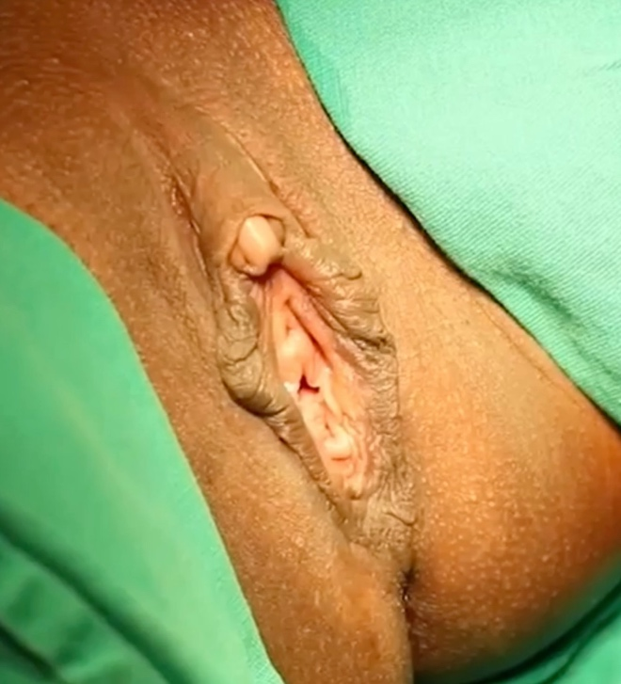**Fig. 1** - Length of the clitoris: anterior commissure of the outer lips to the apex of the glans: 4.5cm and body width and glans 0.7cm. Wrapping of the hood and clitoral body

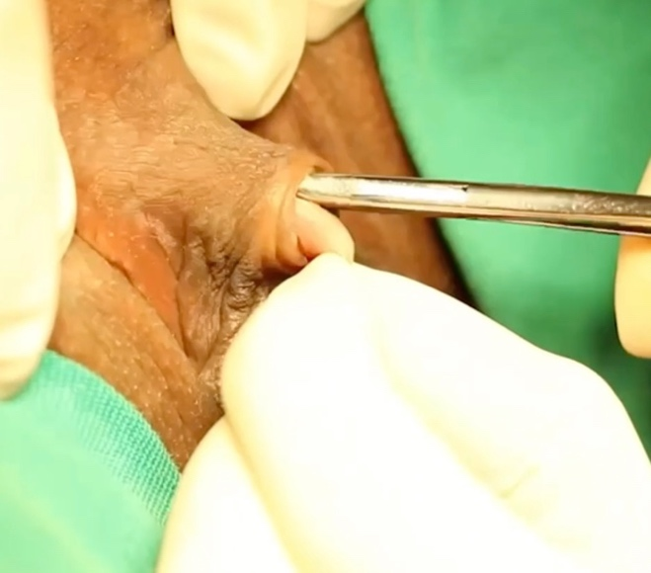**Fig. 2** - After incision in the crown of the glans between 2 and 3 o’clock, an incision is made until the clitoral fascia. With a curved Kelly clamp, a tunneling is done in the membranous layer of the connective tissue with a superficial dissection until it reaches the intermediate suspensory ligament of the clitoris on the suprapubic region.

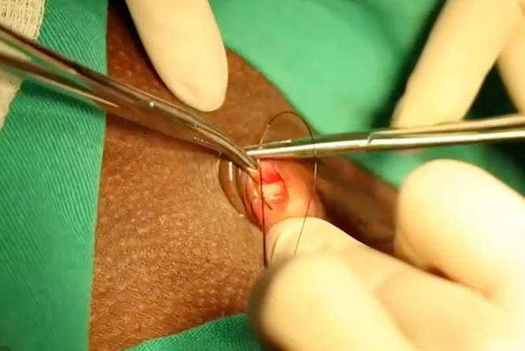**Fig. 3** - With the Kelly clamp, the clamping on this ligament is performed, pulling it until it can be outside and visualized through each of the incisions made in the crown of the clitoral glans, joining the two ends of the fascia (suprapubic and clitoral).

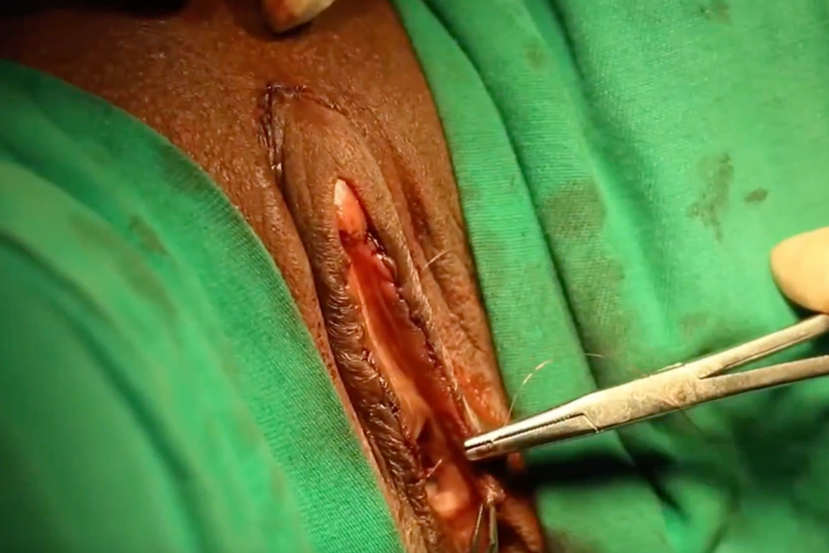 **Fig. 4** – De-epithelization of excess preputial tissue and, depending on each case, should complement the surgery with internal labiaplasty associated with a glansplasty, if necessary.

REFERENCES

1. STRINGER, Mark D.; BECKER, Ines. Colombo and the clitoris. **European Journal Of Obstetrics & Gynecology And Reproductive Biology**, [S.L.], v. 151, n. 2, p. 130-133, ago. 2010. Elsevier BV. <http://dx.doi.org/10.1016/j.ejogrb.2010.04.007>.
2. O'CONNELL, Helen E.; SANJEEVAN, Kalavampara V.; HUTSON, John M.. ANATOMY OF THE CLITORIS. **Journal Of Urology**, [S.L.], v. 174, n. 41, p. 1189-1195, out. 2005. Ovid Technologies (Wolters Kluwer Health). <http://dx.doi.org/10.1097/01.ju.0000173639.38898.cd>.
3. KAEFER, Martin; RINK, Richard C.. Treatment of the Enlarged Clitoris. **Frontiers In Pediatrics**, [S.L.], v. 5, n. , p. 1-11, 28 ago. 2017. Frontiers Media SA. <http://dx.doi.org/10.3389/fped.2017.00125>.
4. YOUNG, H. Hugh; Genital abnormalities, hermaphroditism, and related adrenal diseases. Baltimore (MD): Williams and Wilkins; 1937. P 103-5.
5. SAYER, Robyn A.; DEUTSCH, Aaron; HOFFMAN, Mitchel S.. Clitoroplasty. **Obstetrics & Gynecology**, [S.L.], v. 110, n. 2, p. 523-525, ago. 2007. Ovid Technologies (Wolters Kluwer Health). <http://dx.doi.org/10.1097/01.aog.0000268268.47568.e5>.
6. A KELLING, Joseph; ERICKSON, Cameron R; PIN, Jessica; PIN, Paul G. Anatomical Dissection of the Dorsal Nerve of the Clitoris. **Aesthetic Surgery Journal**, [S.L.], v. 40, n. 5, p. 541-547, 26 nov. 2019. Oxford University Press (OUP). <http://dx.doi.org/10.1093/asj/sjz330>.
7. BOTTER, Charles; BOTTER, Mégane; PIZZA, Chiara; CHARPY, Cécile; PINEAU, Virginie; LAPADULA, Simone; MENINGAUD, Jean-Paul; HERSANT, Barbara. The Suspensory Ligament of the Clitoris: a new anatomical and histological description. **The Journal Of Sexual Medicine**, [S.L.], v. 19, n. 1, p. 12-20, jan. 2022. Elsevier BV. <http://dx.doi.org/10.1016/j.jsxm.2021.10.002>.
8. FERNANDEZ, Nicolas; CHAVARRIAGA, Julián; PÉREZ, Jaime. Complete corporeal preservation clitoroplasty: new insights into feminizing genitoplasty. **International Braz J Urol**, [S.L.], v. 47, n. 4, p. 861-867, ago. 2021. FapUNIFESP (SciELO). <http://dx.doi.org/10.1590/s1677-5538.ibju.2020.0839>.
9. ACIMI, Smail. Clitoroplasty: a variant of the technique. **Urology**, [S.L.], v. 72, n. 3, p. 669-671, set. 2008. Elsevier BV. <http://dx.doi.org/10.1016/j.urology.2008.02.077>.
10. SALLE, João L. Pippi; BRAGA, Luis P.; MACEDO, Nicanor; ROSITO, Nicolino; BAGLI, Darius. Corporeal Sparing Dismembered Clitoroplasty: an alternative technique for feminizing genitoplasty. **Journal Of Urology**, [S.L.], v. 178, n. 4, p. 1796-1801, out. 2007. Ovid Technologies (Wolters Kluwer Health). <http://dx.doi.org/10.1016/j.juro.2007.03.167>.
11. LEAN, W. L.; HUTSON, J. M.; DESHPANDE, A. V.; GROVER, S.. Clitoroplasty: past, present and future. **Pediatric Surgery International**, [S.L.], v. 23, n. 4, p. 289-293, 28 fev. 2007. Springer Science and Business Media LLC. <http://dx.doi.org/10.1007/s00383-007-1893-y>.
12. JACKSON, Lindsey A.; HARE, Adam M.; CARRICK, Kelley S.; RAMIREZ, Denise M.O.; HAMNER, Jennifer J.; CORTON, Marlene M.. Anatomy, histology, and nerve density of clitoris and associated structures: clinical applications to vulvar surgery. **American Journal Of Obstetrics And Gynecology**, [S.L.], v. 221, n. 5, p. 519.e1-519.e9, nov. 2019. Elsevier BV. <http://dx.doi.org/10.1016/j.ajog.2019.06.048>.
13. MERALI, Hasan S.; GARGOLLO, Patricio C.; DIAMOND, David A.. Treatment of clitoromegaly of culturally diverse patients. **Journal Of Pediatric Urology**, [S.L.], v. 5, n. 4, p. 292-296, ago. 2009. Elsevier BV. <http://dx.doi.org/10.1016/j.jpurol.2009.02.200>.
14. GARCÍA‐MESA, Yolanda; CÁRCABA, Lucia; CORONADO, Caesar; COBO, Ramon; MARTÍN‐CRUCES, José; GARCÍA‐PIQUERAS, Jorge; FEITO, Jorge; GARCIA-SUAREZ, Olivia; VEGA, Jose A.. Glans clitoris innervation: piezo2 and sexual mechanosensitivity. **Journal Of Anatomy**, [S.L.], v. 238, n. 2, p. 446-454, 29 set. 2020. Wiley. <http://dx.doi.org/10.1111/joa.13317>.
15. BALAYA, V.; AUBIN, A.; ROGEZ, J.-M.; DOUARD, R.; DELMAS, V.. The dorsal nerve of the clitoris: from anatomy to reconstructive surgery of the clitoris. **Morphologie**, [S.L.], v. 98, n. 320, p. 8-17, Mar. 2014. Elsevier BV. <http://dx.doi.org/10.1016/j.morpho.2013.12.001>.
16. PAPAGEORGIOU, T. Clitoroplasty with preservation of neurovascular pedicles1. **Obstetrics & Gynecology**, [S.L.], v. 96, n. 5, p. 821-823, nov. 2000. Ovid Technologies (Wolters Kluwer Health). <http://dx.doi.org/10.1016/s0029-7844(00)01031-0>.
17. OYAMA, Ian A.; STEINBERG, Adam C.; HOLZBERG, Adam S.; MACCARONE, Joseph L.. Reduction clitoroplasty: a technique for debulking the enlarged clitoris. **Journal Of Pediatric And Adolescent Gynecology**, [S.L.], v. 17, n. 6, p. 393-395, dez. 2004. Elsevier BV. <http://dx.doi.org/10.1016/j.jpag.2004.09.016>.
18. OSTRZENSKI, Adam. Clitoral frenuloreduction: a new surgical intervention. **Heliyon**, [S.L.], v. 5, n. 1, p. 01098, jan. 2019. Elsevier BV. <http://dx.doi.org/10.1016/j.heliyon.2018.e01098>.
19. ZEEMAN, Laetitia; ARANDA, Kay. A Systematic Review of the Health and Healthcare Inequalities for People with Intersex Variance. **International Journal Of Environmental Research And Public Health**, [S.L.], v. 17, n. 18, p. 6533, 8 set. 2020. MDPI AG. <http://dx.doi.org/10.3390/ijerph17186533>.